PRACTICE TASK CLASS -12
FIND COMMAND (continued)

- to find all permissions for files, dir's and links
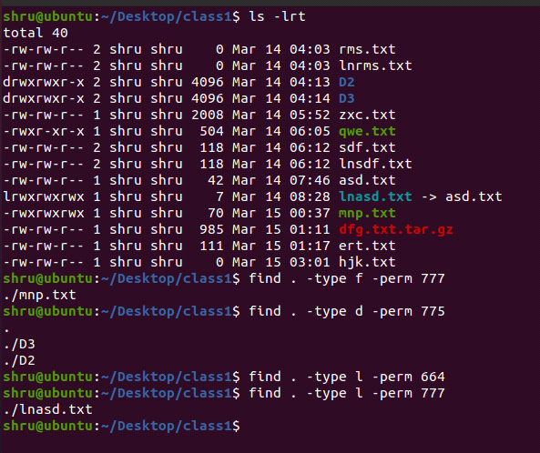
- to find all files, dir's and links created within and before the given time

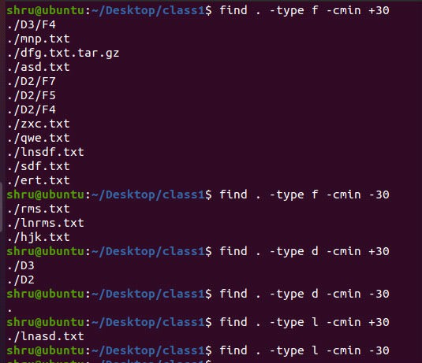

- to find all files, dir's and links modified within and before the given time

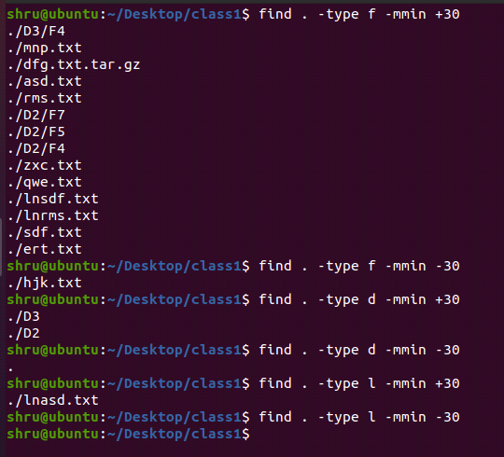

- to find all files, dir's and links accessed within and before the given time

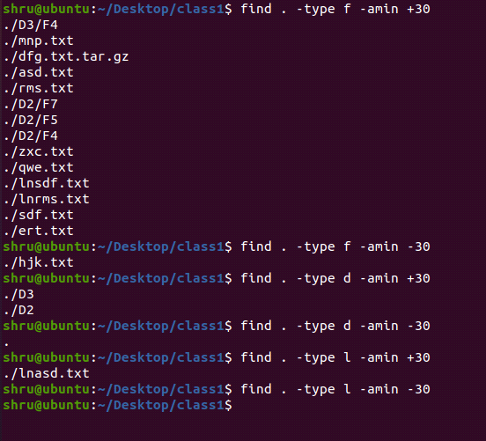

- to find all files, dir's and links based on the size

